Little League Baseball, Inc.

United States Eastern Region

State of Pennsylvania
Association of
District Administrators

Presents the
2026 Pennsylvania State 8-10 YO
Little League Baseball Tournament

July 27th thru August 2nd, 2026

Hosted by Pennsylvania District 27 (Section 8) and Upper Providence Little League

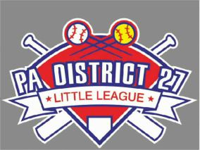

PA District 27 District Administrator  Jeff Bennett, 610-745-3651  JeffBennett.D27@gmail.com | Host League President – Upper Providence  Jim Nastasi, 856-217-2990  jimnastasi@verizon.net
Assistant Tournament Director (D27)  Jason Saylor, 215-275-5378  Jesaylor23@gmail.com | Assistant Tournament Director (UPLL)  Jacob Barnes, 410-919-3311  Jakebarnes11@hotmail.com

Web Site – www.padistrict27.com

Distribution:

Section 8 District Administrators (electronic)
PA State Coordinator (electronic)
Eastern Region Headquarters (electronic)
PA State Tournament Host District Administrator (electronic)

Dear Manager,

You made it to States! Congratulations to you, your players, and your coaches on your success to date.

Welcome to PA District 27 and Upper Providence Little League. We are honored to be your hosts for the Pennsylvania State Tournament for 8-10 YO Baseball. Our objective is to put forward a wholesome, fun, and renowned tournament that will provide life-long memories for all the players, coaches, families, and spectators.

Please send us your Communication and Team Form ASAP so we can include you on all communications.

You will find everything you need in this information packet. Additional information can be found on our D27 website as well as the UPLL website.
D27 Website – www.padistrict27.com
UPLL Website – https://www.up-littleleague.org/

Should you have any questions at any time during the tournament, please contact the District Administrator, Tournament Directors, or the Host League President. All contact information is on the front cover of this information packet.

Teams will not be allowed to compete until their documentation has been submitted, verified, and approved (tournament affidavit, boundary map, player verification forms, residency documentation, medical waivers, coaching clearances, and necessary waivers). Please see your District Administrator immediately if you are unclear of any matters related to the required documentation.

Pennsylvania District 27 and Upper Providence Little League strongly believe that all games are to be decided on the field by the players in accordance with the Little League Official Regulations and Play Rules – in particular, rule XIV(a) – Field Decorum will be strictly enforced:

The actions of players, managers, coaches, umpires, and league officials must be above reproach. Any player, manager, coach, umpire, or league official who is involved in a verbal or physical altercation, or an incident of unsportsmanlike conduct at the game site or any other Little League activity is subject to disciplinary actions by District 27 and the local league board of directors.

Unsportsmanlike conduct by players, managers, coaches, or fans from the opposing team to disrupt the play of any player, especially the pitcher, will not be tolerated and will be dealt with immediately. Managers are expected to control the behavior of their team and fans.

Special thanks to all the volunteers, umpires, District 27 Staff, Upper Providence LL board members, donors, sponsors, vendors, and EMS workers who devoted endless hours to make this tournament a success. Without all of you, none of this would be possible.

Best of luck to all the players, managers, coaches, parents and the fans!!!

Thank you – Have fun and play hard!

Jeff Bennett,

PA District 27, District Administrator

COMMUNICATION FORM

Once your team has won your sectional tournament, please email this form to me, Jeff Bennett at JeffBennett.D27@gmail.com. Please type this form or print very legibly.

** Also complete the Team Form on the following page.

Program: Baseball
Division: 8-10 YO Baseball
Level: PA State Tournament

League Name: __________________________
Section Number: ________________________ District Number: _______
DA’s Name: ________________________________________________________
Cell Phone: _____________________ Email: ________________________
Manager’s Name: ___________________________________________________
Cell Phone: _____________________ Email: ________________________
Coach’s Name: _____________________________________________________
Cell Phone: _____________________ Email: ________________________
Coach’s Name: _____________________________________________________
Cell Phone: _____________________ Email: ________________________
League President’s Name: ____________________________________________
Cell Phone: _____________________ Email: ________________________
Thank you in advance for your cooperation.
Jeff Bennett
PA District 27, District Administrator

TEAM FORM
IMPORTANT – As soon as possible after winning your section tournament, please send a team photo with your Sectional Championship Banner, along with this Team Registration Form.

 | Players Name | Jersey # | Phonetic Pronunciation (if Needed)
1
2
3
4
5
6
7
8
9
10
11
12
13
14
15
16

General Information
Contacts:

Jeff Bennett
District 27 Administrator and Tournament Director
Cell Phone: 610-745-3651 Email: JeffBennett.D27@gmail.com

Jason Saylor
District 27 ADA and Asst. Tournament Director
Cell Phone: 215-275-5378 Email: Jesaylor23@gmail.com

Gary Hall
District 27 ADA-Umpire Chief
Cell Phone: 484-948-7412 Email: umpired27@comcast.net

Jim Nastasi
Upper Providence League President
Cell Phone: 856-217-2990 Email: jimnastasi@verizon.net

Jacob Barnes
Upper Providence Tournament Director
Cell Phone: 410-919-3311 Email: Jakebarnes11@hotmail.com

Lodging:

It is up to each team to secure their own hotel accommodation. Included is a list of hotels in the Upper Providence area. Upper Providence Little League has partnered with the following hotel chains and reserved blocks of rooms with discounted rates. Please use the following codes when reserving rooms.

Hilton:
Hampton Inn & Suites – 100 Cresson Blvd, Phoenixville, PA 610-676-0900
Hilton Garden Inn – 500 Cresson Blvd, Phoenixville, PA 610-650-0880

Other Hotels in the Area:
Courtyard by Marriott – Philadelphia Valley Forge, 600 Campus Dr, Collegeville, PA 484-974-2600
Homewood Suites – 681 Shannondell Blvd, Norristown, PA 19403 610-539-7300
SpringHill Suites – 875 Mancill Mill Rd, King of Prussia, PA 610-783-1400

Team Meals:

Meals will be provided for all teams’ players and coaches following their games at the complex. Numerous local businesses and restaurants have donated to make this possible. More information will be provided for the times and location of the team meals.

Concessions:

The Upper Providence Little League complex will be offering a full-service concession operated by its volunteers throughout the tournament. A wide variety of items will be available. The concession stand will accept cash and Venmo.

Tournament Liaisons:

Each team will be assigned an Upper Providence Volunteer who will serve as their team aunt/uncle for the tournament. They will guide you through the week and help you with anything you may need. Liaisons will reach out to you prior to your arrival to introduce themselves and answer any questions you may have.

Teams will be introduced to their respective Aunt and/or Uncle at the tournament banquet on Sunday evening. Some of the attractions are listed below:

- Arnolds Family Fun Center
- King of Prussia Mall
- American Treasure Tour Museum
- French Creek State Park
- Sky Zone
- Movie Tavern Collegeville
- Valley Forge Historic Park

Tournament T-Shirts:

Tournament T-Shirts may be pre-ordered by email to Jacob Barnes (Asst. Tournament Director from UPLL). His contact information can be found on the cover of this packet.

Hospital / Urgent Care Facilities:


550 S. Goddard Blvd, King of Prussia, PA

265 Schuylkill Rd, Phoenixville, PA 19460

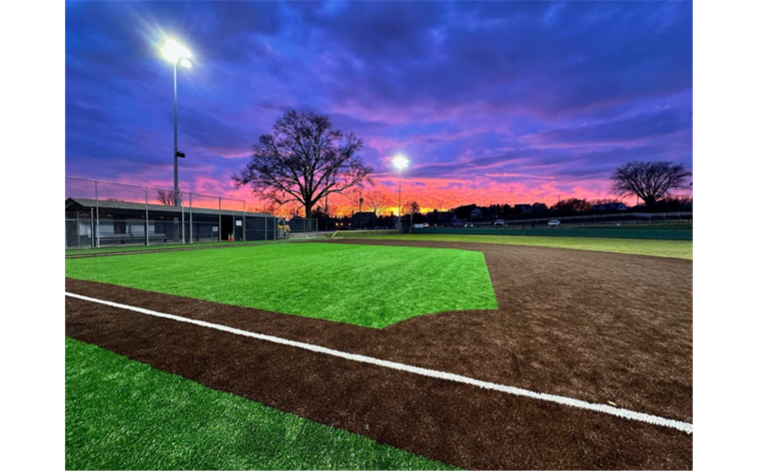
Tournament Site:

Upper Providence Little League
MacFarlan Park,
250 Greentree Road,
Phoenixville, PA 19460

LITTLE LEAGUE PLEDGE
I trust in God
I love my country
And will respect its laws
I will play fair
And strive to win
But win or lose
I will always do my best

PARENT/VOLUNTEER PLEDGE
I will teach all children to play fair and do their best
I will positively support all managers, coaches and players
I will respect the decisions of the umpires
I will praise a good effort despite the outcome of the game

Parking:

There will be ample parking located adjacent to the complex between the Majors field, alongside the woods of the Rookie A and Minors field, Macfarland Park and the Black Rock Firehouse. Volunteers and signs will be onsite to assist with parking matters.
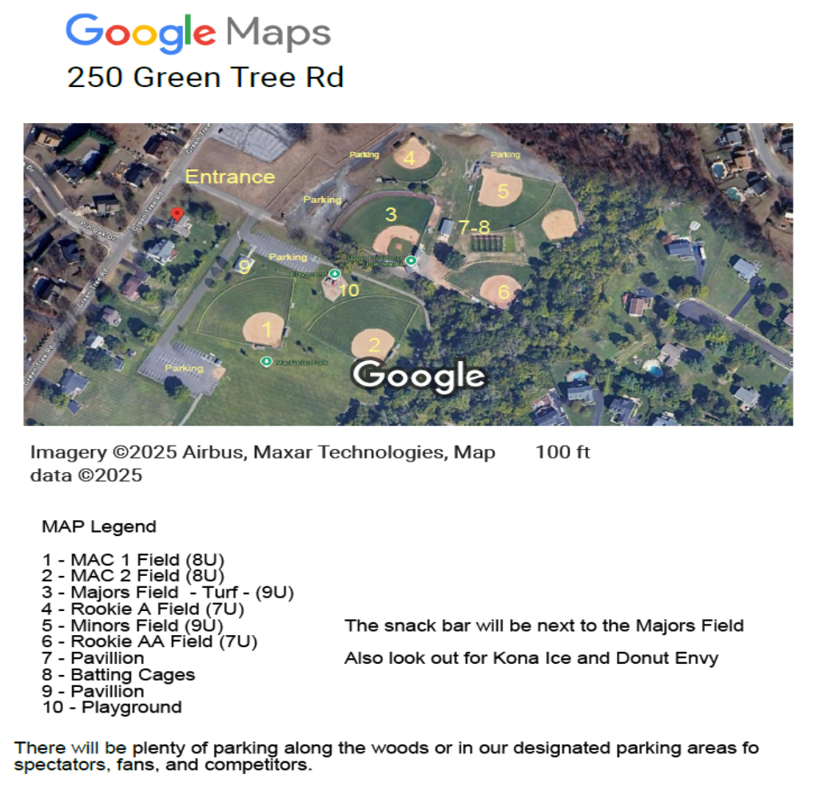

Schedule of Events
Sunday, July 26, 2026 –

Team Check-in –

Check-in for teams will be held on Sunday (7/26) from 1:00-3:00 pm at MacFarlan Park, the home of Upper Providence Little League. At this time, the manager should meet with the D27 District Admin Staff to submit and review all their required documentation. We will be meeting at the Pavilion behind the main field.

Coaches Meeting –

There will be a mandatory meeting at the pavilion at MacFarlan Park on Sunday (7/26) at 3:30 pm for all managers and coaches listed on the official affidavit. Any League Presidents and/or District Administrators travelling with the team may attend as well. The meeting will be run by the PA District 27 Staff, D27 Umpires, and UPLL League Officials. This meeting will take place at the Pavilion behind the main field.

Tournament Banquet –

Upper Providence Little League will host a pre-tournament Catered Dinner on Sunday (7/26) from approximately 5:00 to 8:00 pm. The banquet will be set up under the batting cage pavilion at MacFarlan Park. All teams are expected to attend the banquet. The dinner is free for all players and coaches. Additional information regarding tickets parents and fans will be available soon.

Practice –

If you’d like to have a practice in the morning of Sunday (7/26), please contact the Tournament Staff to arrange for a field and/or batting cage for practice. All practices will be concluded by 1:00 pm.

Monday, July 27, 2026 –

Games – Consult the game schedule for game times in the morning.

Opening Ceremony – On Monday (7/27), we will have an opening ceremony at approximately 2:45 pm where each team will be introduced and led onto the field. We will introduce the Tournament and District Staff as well as the District Umpires. Teams should be prepared to line up around 2:15-2:30 pm.

Tuesday, July 28 thru Sunday, August 2, 2026 –

Games – Consult the game schedule for game times for days 2 thru 7

TOURNAMENT RULES
ZERO TOLERANCE POLICY

District 27 always promotes good sportsmanship and at all levels of play. Throughout this tournament, any conduct that is meant to demean or incite opposing teams, spectators, or officials will not be tolerated. All verbal comments must be positive and encouraging. Spectating offenders will be removed from the complex for the remainder of the tournament. Coaches or players who are ejected from a game, per LL tournament rules, will not be permitted to participate in the next scheduled game.

The facility is smoke, tobacco, and alcohol free. Any violation of this policy will result in immediate removal from the complex. Thank you for your cooperation.

- The PA State LL Tournament will be a double elimination tournament.
- Playing rules will be per LL Majors Baseball Tournament rules. All rules will be strictly enforced by the tournament staff and umpires.
- Pitching logs must be verified and signed immediately after each game.
- The Tournament Director and staff reserve the right to change game dates and starting times due to inclement weather.
- The team travelling furthest to the complex will occupy first base for each game. The team in the first base dugout will call the coin toss to determine home and away.
- Both teams will have sufficient warm up time on the Majors field. Times can be adjusted on an as needed basis.
- The team manager is responsible for uniforms and equipment.
- All players must be in uniform with the LL approved patch. The patch may NOT be printed on the uniform. Must be the physical patch.
- Only managers, coaches, and players listed on the official tournament eligibility affidavit are permitted in the dugout or playing field. Under no circumstance will coaching (or assistance to coaching) be permitted by anyone outside of the dugout area during games. This includes pre-game warm-ups.
- If you plan to reference a score book or GameChanger, then that scorekeeper must be one of the three coaches on the affidavit and in the dugout.
- Game balls will be provided by Upper Providence Little League and District 27.
- Both teams will line up as directed by the Tournament Director and introduced and remain there for the National Anthem and Little League Pledge.
- Both teams will meet at the home plate area immediately at the conclusion of the game and tip hats as a show of sportsmanship and respect.
- When a team is eliminated from the tournament, the eliminated team will be presented with tournament pins.
- At the conclusion of the tournament, the winning team will be awarded the PA Championship Flag, a team trophy and player medallions.

PA State Tournament (2026) – 8-10 YO Baseball (BB-10)
Hosted by PA District 27 and Upper Providence Little League

G# | Day | Date | Time | Team 1 | Score | vs | Team 2 | Score
01 | Mon | 27-Jul-2026 | 10:00 am | PA Section 2 |  | vs | PA Section 5
02 | Mon | 27-Jul-2026 | 12:30 pm | PA Section 4 |  | vs | PA Section 7
 | Mon | 27-Jul-2026 | 2:45 pm | Opening Ceremony
03 | Mon | 27-Jul-2026 | 4:30 pm | PA Section 3 |  | vs | PA Section 6
04 | Mon | 27-Jul-2026 | 7:00 pm | PA Section 1 |  | vs | PA Section 8
05 | Tues | 28-Jul-2026 | 10:00 am | LG-2 |  | vs | LG-3
06 | Tues | 28-Jul-2026 | 1:00 pm | LG-1 |  | vs | LG-4
07 | Tues | 28-Jul-2026 | 4:00 pm | WG-1 |  | vs | WG-2
08 | Tues | 28-Jul-2026 | 7:00 pm | WG-3 |  | vs | WG-4
09 | Wed | 29-Jul-2026 | 4:00 pm | WG-5 |  | vs | LG-8
10 | Wed | 29-Jul-2026 | 7:00 pm | LG-7 |  | vs | WG-6
11 | Thurs | 30-Jul-2026 | 4:00 pm | WG-7 |  | vs | WG-8
12 | Thurs | 30-Jul-2026 | 7:00 pm | WG-9 |  | vs | WG-10
13 | Fri | 31-Jul-2026 | 6:00 pm | LG-11 |  | vs | WG-12
14 | Sat | 1-Aug-2026 | 10:00 am | WG-11 |  | vs | WG-13
15 | Sun | 2-Aug-2026 | 1:00 pm | WG-14 |  | vs | If Necessary

** Teams travelling the furthest to the tournament site will occupy the first base dugout and will call the coin toss for home and away at the pre-game plate meeting with the umpires. Once all teams have been determined, District 27 will calculate and publish the distances to the Tournament Site.
